Trent patterson September 9, 2016

Dorado - The Tiger of the River

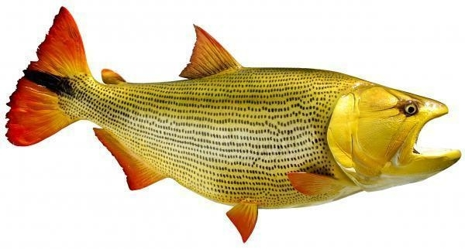

Dorado - The Tiger of the River
This fish likes to hunt other fish. It is a catch-and-release game fish, after they are captured they are then unhooked and returned to the water. There are many threats to the dorado’s such as; poaching, pollution, irrigation dams, and habitat loss stand as threats to the dorado’s survival, but a group of dedicated anglers are leading new grass roots efforts to protect it for the future.

